
St Monica’s (Milton) Primary School
Standards & Quality Report
Session 2024 – 2025

This summary report is provided for parents/carers and partners to outline our achievements and improvements during session 2024 - 2025 and to share our improvement priorities for 2025 - 2026. Throughout last session we took forward our improvement priorities as detailed in our school improvement plan. Using our approaches to self-evaluation, we have detailed in this report the impact of our work and identified how we plan to continue to improve outcomes for our children and young people.

The context of the school
St. Monica`s (Milton) Primary School is a Catholic School which is part of All Saints Learning Community.
The school is situated in the Milton area of Glasgow.

Since returning to school in August 2025 our school roll is 405 children whereas, before the summer holidays in June 2025 we had 416 children. Due to the area and types of accommodation available means that are school roll often fluctuates. The school is in an area of high deprivation as set out by the Scottish Index of Multiple Deprivation (SIMD) of which, 83% of children are from SIMD 1-2 and 88% from SIMD 1-4. 43% are entitled to free meals and 30% of children have English as an Additional Language (EAL). We currently have 26 languages spoken within the school community.

Our achievements and improvements 2024 – 2025
St Monica’s (Milton) Primary School continues to have a strong faith and as such, our Catholic values permeate our vision, values and aims. Our Values were slightly tweaked this year with consultation of the children, parents and staff to reflect what we want to live by as a school:
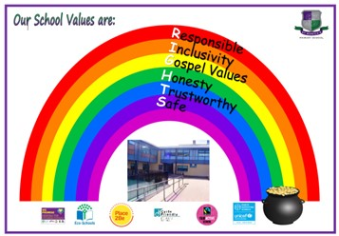
The values we live by are evident in our curriculum and in the daily practice of all staff. Almost all children continue to be engaged, motivated and interact well during learning experiences almost all of the time.

Key developments (leadership of change) (QI 1.3)
Staffing
Our staff continues to change due to members taking up temporary promoted posts in other schools in the authority as well as staff being absent, retiring, on maternity or paternity leave. This therefore has meant that other staff within the school have been able to take on positions of responsibility or promoted roles which has then meant that there is consistency within the school. 2 of our Class Teachers have taken on a shared Principal Teacher position on an ‘acting’ capacity giving them an opportunity to grow and development their leadership skills and help drive developments forward within the school. We are very fortunate to have a staff team who want to take on areas of the curriculum and help to develop this.

Leading Change
Most staff are involved or lead change within the school. The staff involved are leading elements of the curriculum such as Literacy, Numeracy, HWB, Committees (Pupil Voice, Enterprise, Eco, Fairtrade), Groups such as the Liturgy Group and Minnie Vinnies. A few of the Support Staff are also leading change from ensuring children are properly supported with their medical needs, administering first aid, taking part in Committees and their links to the curriculum or supporting children’s well-being. Almost all staff are positive about future change and willing to take responsibility for implementing this change.

The school continues to seek opinions from parents, carers and children on how to take the school forward through providing opportunities to have their voices heard, for example Focus Groups, Questionnaires, Glow Forms and informal meetings. This is increasing steadily but depends on what the school are seeking opinions on.
Developments in learning, teaching and assessment (Q1 2.1)
Spiritual Development
Our P3s, P4s and P7s continue to celebrate and make the Sacraments of the Eucharist, Reconciliation and Confirmation with 89 children making them. 28 of our P3s made their Reconciliation, 26 P4s made their First Holy Communion and 35 P7s made their Confirmation. The children making their Sacraments are supported effectively by the teachers and this is further aided by St Augustine’s Parish Catechists, Father Paul McAlinden and Deacon James Ward. Our P7s received the Sacrament of Confirmation this year by Archbishop William Nolan which took place in March 2025.
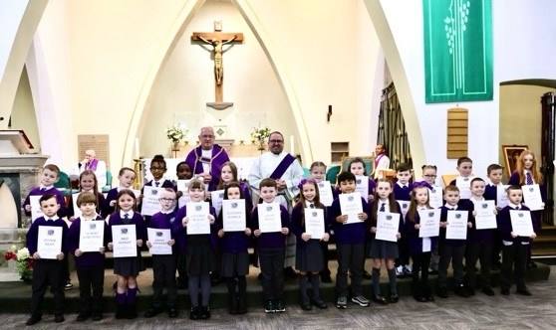

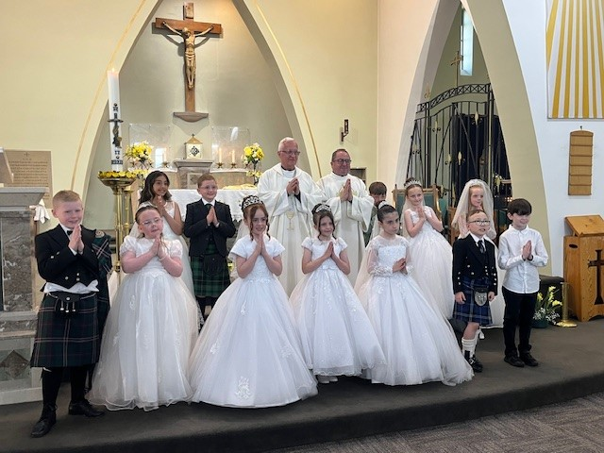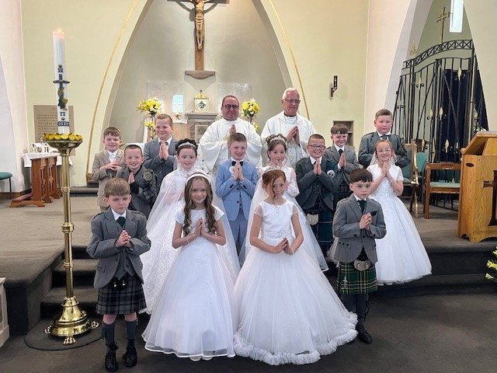

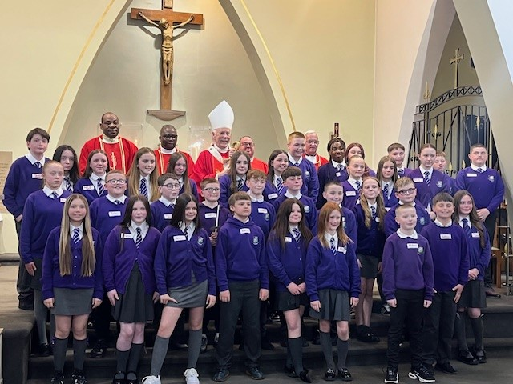
Due to 2025 marking the Jubilee Year within the Catholic Church, some children from P6 and P7 who are in the Liturgy Group joined an All Saints Community Walk of Witness. They walked around schools and parishes of the Learning Community in a celebration of faith.

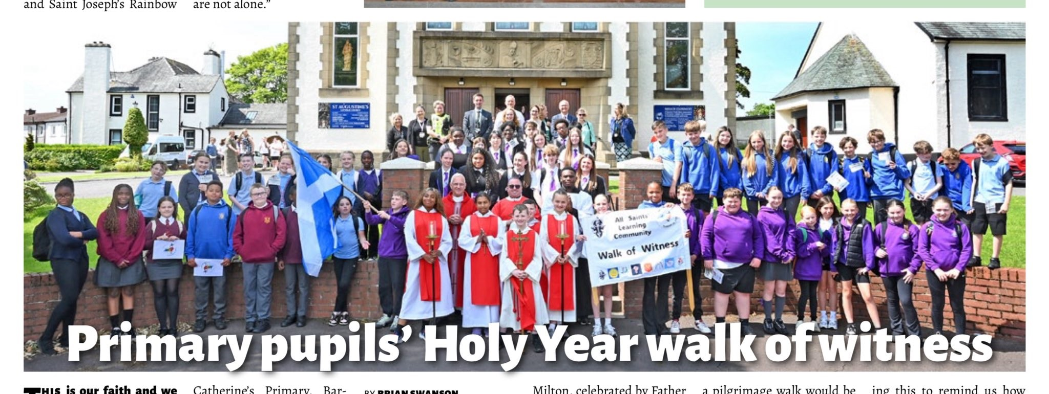

We had many whole school events this year which included:
- First Friday Masses in St Augustine’s
- Class Assemblies where parents and carers came along
- Enterprise Day to make items for our Christmas Fayre
- In school Pantomine – ‘Peter Pan’
- P1-P3 Nativity
- Christmas Fayre
- Whole School Fun Day – Silent Disco, Ice-cream Van, Movie
- Family Learning Sessions
- Parent Council Discos House Treats – Bowling, Inflata Nation, Cinema
- P7 Leavers’ Show – ‘We’re All Going on a Summer Holiday’

We are fortunate that we are able to have after school clubs from a variety of Sports Coaches throughout the year as well as a few our teachers taking clubs too. Our Principal Teachers, our Depute Head Teacher, EAL Teacher and our Challenge Leader of Learning (CLOL) also arranged Family Learning Sessions at points throughout the year which were well received by parents and carers One of these sessions were:

English for Speakers of Other Languages (ESOL) Family Learning Sessions
Our EAL Teacher and area Family Learning Officer held family sessions for families who would benefit from more exposure to English. They were supported by some of our Language Ambassadors from across the school to participate in fun activities. We hope to continue this in 2025-2026 as well as looking at more formalised ESOL training for parents and carers.
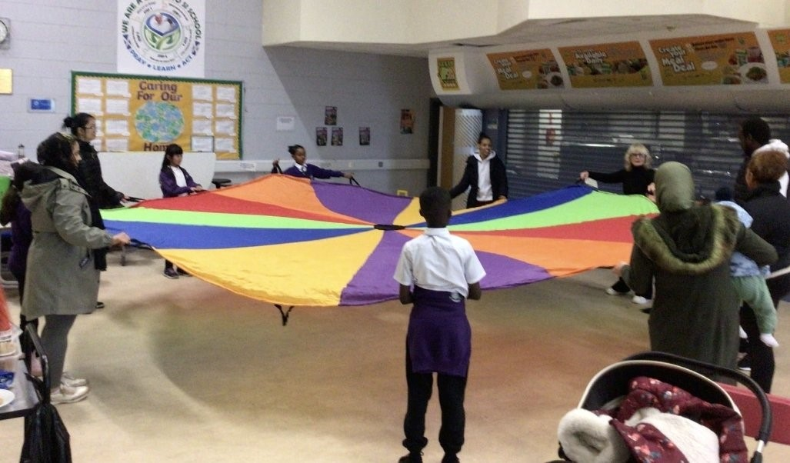
School Awards:
- Lord Provost’s Bronze Award for STARS (School Travel and Road Safety) – October 2024
- Renewal of Cycling Friendly School Award – February 2025
- Keeping the Promise Establishment Award – June 2025

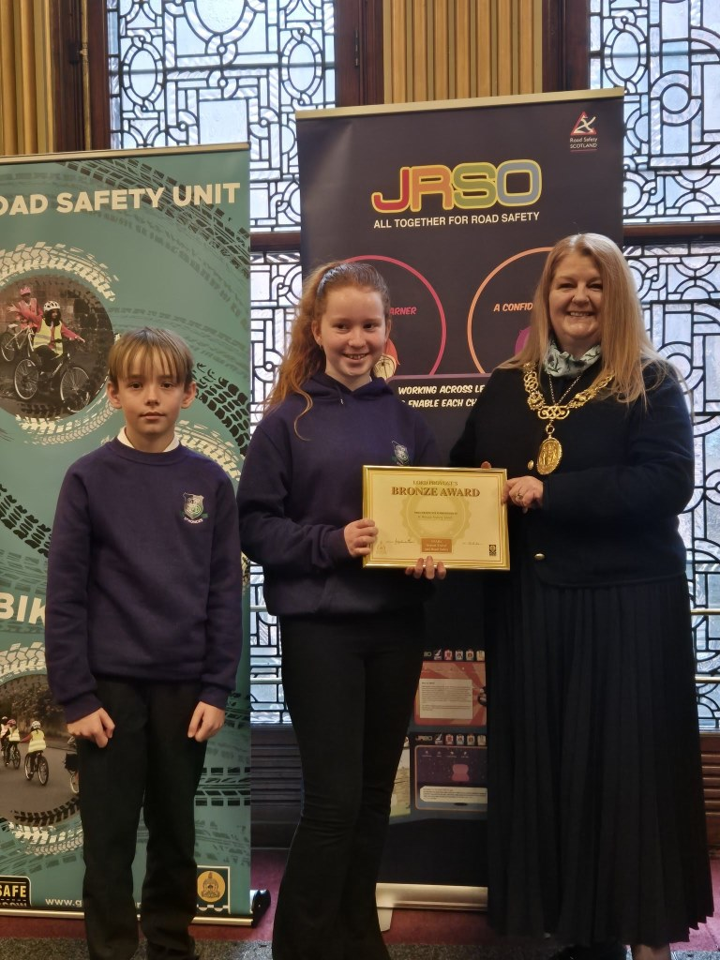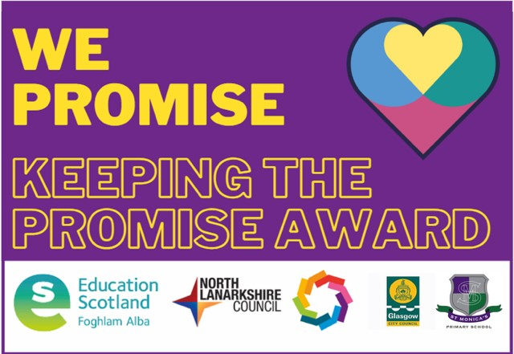

The children were represented at various events in the city across the year including:

Glasgow Pupil Forum
At the end of the session 2024-2025 we had 4 wonderful pupils represent the school at the Glasgow Pupil Forum in the City Chambers where they presented to schools across the city about our Peer Mediation Journey. They were confident individuals and presented to Primary and Secondary Schools.
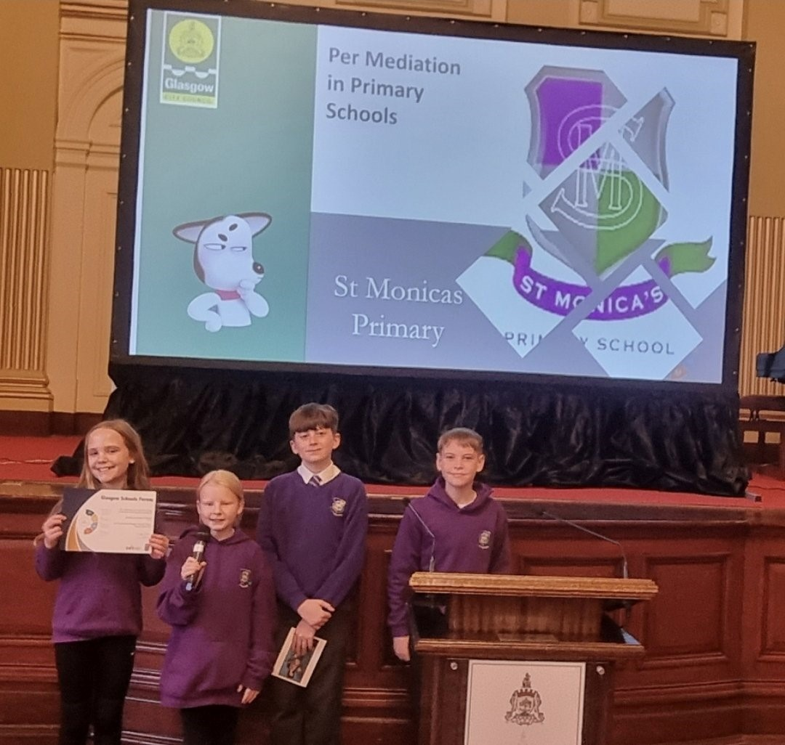

The school choir showcased their God given talents by singing:
- St Joseph’s Care Home, Robroyston – November 2024
- Carols in the Car Park – December 2024

Progress in promoting well-being equality and inclusion (QI 3.1)
Supports
As a school we continue to ensure that our children are well supported, and we do this in various ways. Our two Well-being Bases continued to run 3 days a week allowing some children to work in smaller groups, develop teamwork skills or aid their emotional health and well-being. These Well-being Bases have two designated teachers and a Support for Learning Worker to ensure there was a consistent approach, and the children knew the expectations when they were there.

Our Place2Be service that we have within the school continues to thrive with many children self-referring themselves to talk to our Place2Be School Project Manager. We also have many identified children working one on one with one of our Counsellors following discussion with parents and carers. This year, due to similar needs, our School Project Manager and a Counsellor were able to hold Group Sessions which were positive and something that we hope to continue.

This year we had more referrals to our Place2Be Family Practitioner. She worked with families to undertake Personalised Individual Parenting Training (PIPT) and almost all parents and carers involved found this useful, either by building more confidence and skills or strengthening family relationships.

Having Place2Be within our school has also given us an opportunity to work with other agencies to showcase what we do or support our children’s mental health and creativity. This year we had:

Young BAFTA Roadshow with Place2Be
Place2Be teamed up with Young BAFTA and have gone into schools to support children's mental health and to support children's creativity!

We had the Young BAFTA Roadshow in the school in September 2024 working with P4-P7. With them they brought 2 celebrities, Ben Shires and Robyn Richford. They were very impressed with the work that happens in our school as well as the children, their behaviour and their ideas.

Please click on the link to see an article from Place2Be:

https://www.place2be.org.uk/about-us/news-and-blogs/2024/september/the-young-bafta-roadshow-with-place2be-arrives-in-scotland/

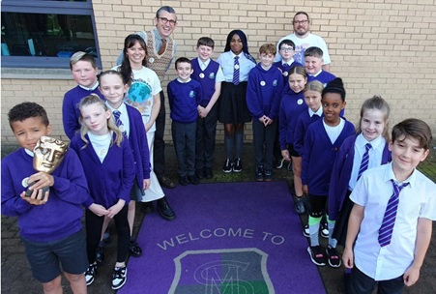

Scottish Junior Forestry Award
Supports are always put in place to help children whilst in school. Sometimes it is beneficial to get the children outdoors. Our Upper Well-being Teacher worked with 15 children in taking part in the Scottish Junior Forestry Award. Taking part in this equipped the children with the practical ability to assist in woodland management in their schools and local communities.

Care Experienced Children
85% of our Care Experienced Learners benefiting from attending our Learning for Life Club where they worked with teachers after school to receive some addition tutoring. This is something we will continue in 2025-2026.

Peer Mediators
Primary 7 Peer Mediators have been working hard to support children in our playground with any conflicts that may arise. They are available to help at every break and lunchtime and they are trained in using our Five Restorative Questions to support our younger pupils in resolving conflict. They then helped to train up children before the end of term for the year 2025-2026.
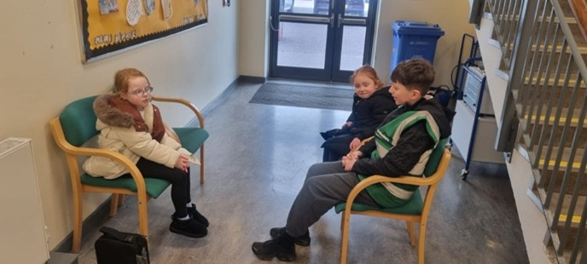
ASN Coffee and Connect
This year we established an ASN Coffee and Connect Group where families of children with additional support needs would be to discuss how things were going and as a support to one another. Despite it only be new we had 2% of our school attend this. We hope that this will continue to grow and develop next session.


Community
We continue to support our families in as many ways as we can. We continue to work with the Fareshare Scheme where we receive ‘best before’ items from our local Tesco, and we put these out to our school community to take if they need. This sits alongside our Community Cupboard and Pre-loved Uniform Rail. The use of our Financial Inclusion Support Officer (FISO) increased this year with many families feeling the support and advice offered was useful.
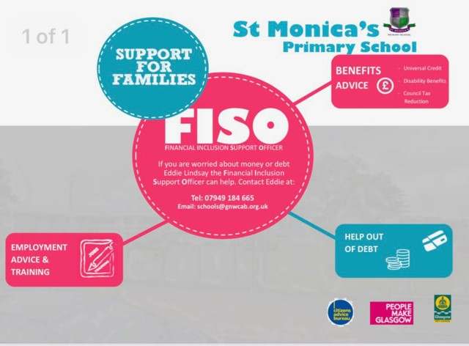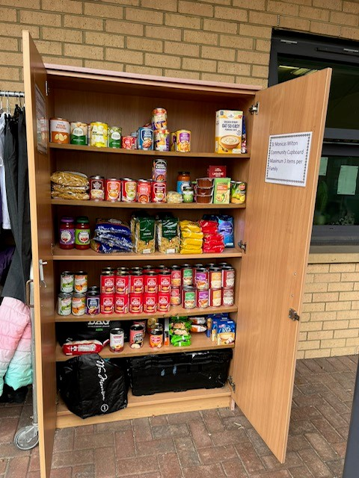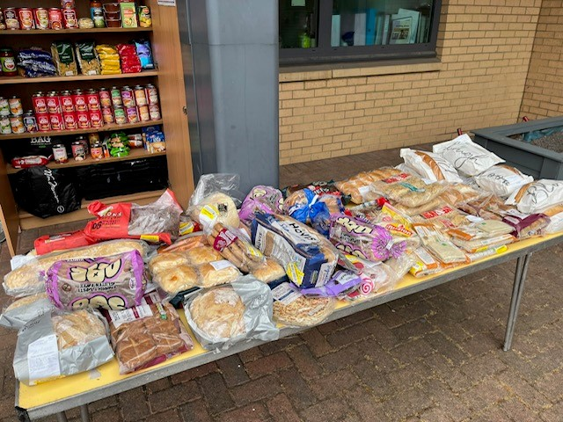

Other supports the school are continuing to offer children:
- Seasons for Growth
- Bikeability
- Various clubs
- Individual check-ins

Progress in children’s learning /raising attainment and recognising achievement (QI 3.2)
Pupil Equity Funding
Raising attainment is further supported by the Scottish Government with the help of Pupil Equity Funding (PEF) and, as a school, we are fortunate to receive £218,050. This year we continued to use some of the money to employ more staff (1.6 Teachers, 2 Probationer Teachers, 1.6 SfLWs, enhancement to make a DHT) which helped towards supporting children with their learning, targeting children whose attendance was lower which was affecting their learning and supporting some children who are vulnerable and need further supports put in place. We also continue to have the Place2Be Service within our school 2 and a half days a week which helps us to support our children and families in a variety of ways.

Raising Attainment
We continue to work on raising attainment across the school and gather data on children who have achieved a Curriculum for Excellence Level at the end of P1, P4 and P7. With the use of PEF money, we continue to work on raising attainment in literacy and numeracy. Figures for some have increased and some have decreased however, we understand that every child is different and learns at their own level so will continue to put interventions in where we can.

 | T & L |  | Reading |  | Writing |  | Numeracy
Stages | 2024 | 2025 | 2024 | 2025 | 2024 | 2025 | 2024 | 2025
P1 | 88.1% | 91.4% | 88.1% | 66.1% | 86.4% | 64.4% | 88.1% | 78.0%
P4 | 91.9% | 92.3% | 53.2% | 73.1% | 50.0% | 69.2% | 51.6% | 80.8%
P7 | 87.3% | 91.4% | 71.4% | 65.7% | 61.9% | 48.6% | 74.6% | 52.9%

Opportunities to showcase talents
At our weekly assemblies we encourage children to showcase their achievements which often involves children talking about their wider achievements – successes in gymnastics, football, dance, weightlifting etc. We celebrate this by uploading onto our social media platforms for parents and carers to see.

We have coaches come in to school and put on lunchtime or after school clubs to encourage children to get involved and stay healthy. In 2024-2025, 56% of our children took part in clubs with dance, football and multisport/games being the top 3. Many of our teaching staff also lead clubs afterschool with a few support staff helping too.

We had our first Drama Club this year that some of our teachers and Support staff were involved in. They put on a wonderful Showcase after school for families which focussed around the show, High School Musical. It was a great success and encouraged some of our children to show off their God given talents.
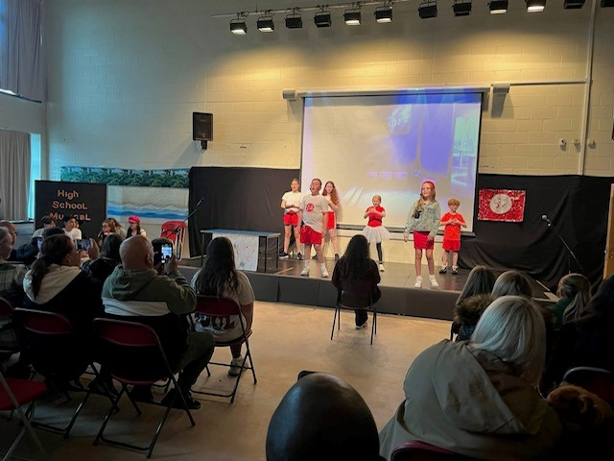
Attendance and Exclusion data
Attendance
As of September 2025, our attendance rate is 91.6%.
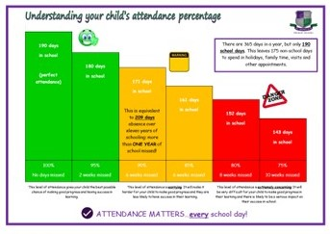
Exclusions
In 2024-2025 we had 3 exclusions.
Since returning in August 2025 to September 2025 we have had no exclusions.

Our improvement plan priorities 2025 – 2026
1. Challenge: Improve the quality and consistency of teaching and learning for all
- To improve the learning experiences within Expressive Arts
- To improve the quality of Learning & Teaching in Religious Education throughout the school
2. Challenge: Improve our curriculum
- To develop children’s appreciation for different cultures.
- To develop Interdisciplinary Learning further across the school.
3. Challenge: Get it right for everyone in St Monica’s, including improved wellbeing.
- To increase the overall wellbeing and ensure everyone is included.

We will also continue to work on raising attainment in Literacy and Numeracy.

 | How Good Is Our School 4 Quality Indicator (QI) | Evaluation
 | Leadership of Change (QI 1.3) | Very Good
 | Learning Teaching and Assessment (QI 2.3) | Good
 | Ensuring Wellbeing Equality and Inclusion (QI 3.1) | Very Good
 | Raising Attainment and Achievement (QI 3.2) | Good

How to find out more about our school
Contact us directly if you require further information about our school or if you wish to comment on this report.

Our contact e-mail address is: headteacher@st-monicasmilton-pri.glasgow.sch.uk

Our telephone number is: 0141 772 0026

Our school address is: St Monica's (Milton) Primary School, 200 Liddesdale Road, Glasgow, G22 7QR

Further information is available in: newsletters, the school website, social media and the school handbook

Website: www.st-monicasmilton-pri.glasgow.sch.uk

X: @StMonicaMilton

Facebook: St Monica’s – Milton Primary School

Please contact us directly if you require further information or if you wish to comment on the report.

