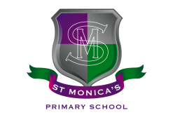
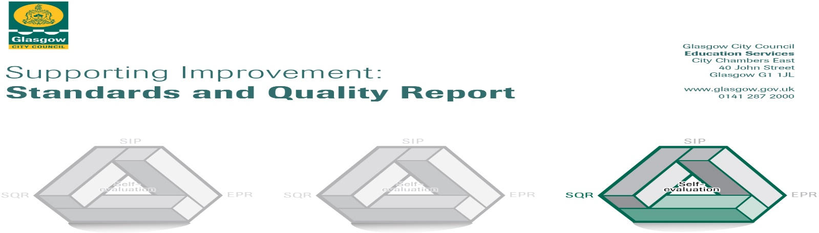
St. Monica’s (Milton) Primary School
September 2024

The summary report is provided for parents/careers and partners to outline our achievements this session and our priorities for next session. Throughout this session we have taken forward our priorities as detailed in our school improvement plan. Through our processes of self-evaluation, we have identified how we can improve outcomes for our children and young people.

Our achievements and improvements this year.
We would like to highlight the following improvements/achievements:

St Monica’s (Milton) Primary School continues to have a strong faith and as such, our Catholic values permeate our vision, values and aims. This is evident in our curriculum and in the daily practice of all staff. This results in very positive relationships across the school based on our Catholic social teaching. Almost all children continue to be engaged, motivated and interact well during learning experiences almost all of the time.

This year we had a few changes to our staff due to members of staff being promoted and moving to new schools. Two of our Depute Head Teachers moved on to take up acting Headteacher positions and one of our Class Teachers moved on to take up an acting Principal Teacher position. Although sad for our school community, they are great opportunities for our staff members and highlights the fact that they are being given relevant opportunities to develop their leadership skills. Because of these changes it has given more staff opportunities to take on acting positions within the school demonstrating leadership of change is well and truly embedded.

As a school we continue to ensure that our children are well supported, and we do this in various ways. Luckily, we have been able to create and maintain two Well-being Bases allowing some children to work in smaller groups, develop teamwork skills or aid their emotional health and well-being. These Well-being Bases had two designated teachers and a Support for Learning Worker. Having a consistent approach and designated staff members helped the children involved to feel better connected to the school. Unfortunately, with budget cuts being implemented in session 2024-2025 will mean that the Well-being Bases will not be able to run as much as they previously have, however, the school will continue to support identified children as much as possible.

Our Place2Be service that we have within the school continues to thrive with many children self-referring themselves to talk to our Place2Be School Project Manager. We also have many identified children working one on one with one of our Counsellors following discussion with parents and carers. A few teachers have undertaken the Place2Be Mental Health Champions course which further supports our children and ensures that, as a school, we are doing all we can to ensure that children’s well-being and mental health are being addressed. Having Place2Be within our school has also given us an opportunity to showcase our school to others and this year we managed to do this to:
- The Postcode Lottery
- Catherine Roche, Chief Executive of Place2Be
- The Royal Navy - HMS Glasgow

Our focus for our School Improvement Plan (SIP) continues to be about improving literacy, numeracy and health and wellbeing. As part of the Scottish Government’s aim to raise attainment, we continue to target children to help improve this. This is supported with the help of our teachers, Support for Learning Workers (SfLWs), Challenge Leaders of Learning (CLOLs) and Digital Leaders of earning (DLOLs). The majority of children are making progress in literacy and the majority of children are making progress in numeracy.

Raising attainment is further supported by the Scottish Government with the help of Pupil Equity Funding (PEF) and, as a school, we are fortunate to receive £218,050. This year we used some of the money to target children whose attendance was lower which was affecting their learning. We had PEEK in again as well as a Car Valeting Training Programme. The children enjoy working with other agencies.

The majority of P3s, P4s and P7s continue to celebrate and make the Sacraments of the Eucharist, Reconciliation and Confirmation and are supported effectively by the teachers. This is further aided by St Augustine’s Parish Catechists and Father Paul McAlinden. Our P7s received the Sacrament of Confirmation this year by Archbishop William Nolan. This took place in November 2023.

As a school, we continue to work alongside our partners:
- Caledonian Club
- Sir Thomas Lipton Foundation – Buoyed Up Programme
- Place2Be
- PEEK
- Active School’s Co-ordinator
- Primary Swimming Programme

We also had many other visitors into the school to work alongside teachers and staff to create meaningful learning experiences for our children. These included:
- Create Youth Music Initiative (YMI) Tutor
- Road Safety Officer
- Various Sports Coaches
- Generation Science
- Violin and Guitar Tutors

We had many whole school events this year which included:
- Class Assemblies where parents and carers came along
- First Friday Masses in St Augustine’s
- Enterprise Day to make items for our Christmas Fayre
- P1-P3 Nativity
- Christmas Fayre
- In school Pantomine
- House Treats – Bowling, Flip Out
- P7 Leavers’ Show – ‘I’m An 11-Yr-Old…GET ME OUT OF HERE!’
- Parent Council Discos
- Summer Fayre

We are fortunate that we are able to have after school clubs from a variety of Sports Coaches throughout the year as well as a few our teachers taking clubs too. Our Principal Teachers, our Depute Head Teacher, EAL Teacher and our Challenge Leader of Learning (CLOL) also arranged Family Learning Sessions at points throughout the year which were well received by parents and carers.

School Awards:
- Eco-Schools Green Flag Award – July 2024
The school choir showcased their God given talents by singing:
- Blessing of the Crib in George Square – November 2023
- St Jospeh’s Care Home, Robroyston – November 2023
- Carols in the Car Park – December 2023
- St Enoch’s Centre for the Prince & Princess of Wales Hospice – December 2023

Here is what we plan to improve next year.
We want to continue to focus on and improve:-

1. Challenge: Improve the quality and consistency of teaching and learning for all
- To improve practice with Literacy and Numeracy
- To improve the quality of Learning & Teaching in Religious Education throughout the school
2. Challenge: Improve our curriculum
- To develop children’s appreciation for different cultures.
3. Challenge: Get it right for everyone in St Monica’s, including improved wellbeing.
- To increase the overall wellbeing and ensure everyone is included.
- To track and Improve Children’s Health and Wellbeing across the school
- To implement Restorative Approaches throughout the school

How can you find out more information about our school?
Please contact us directly if you require further information or if you wish to comment on the report.

The contact e-mail address is: headteacher@st-monicasmilton-pri.glasgow.sch.uk

Our telephone number is: 0141 772 0026

Our school address is: St Monica's (Milton) Primary School, 200 Liddesdale Road, Glasgow, G22 7QR

Further information is available in: newsletters, the school website, social media and the school handbook

Website: www.st-monicasmilton-pri.glasgow.sch.uk

X: @StMonicaMilton

Facebook: St Monica’s – Milton Primary School

