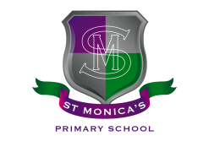
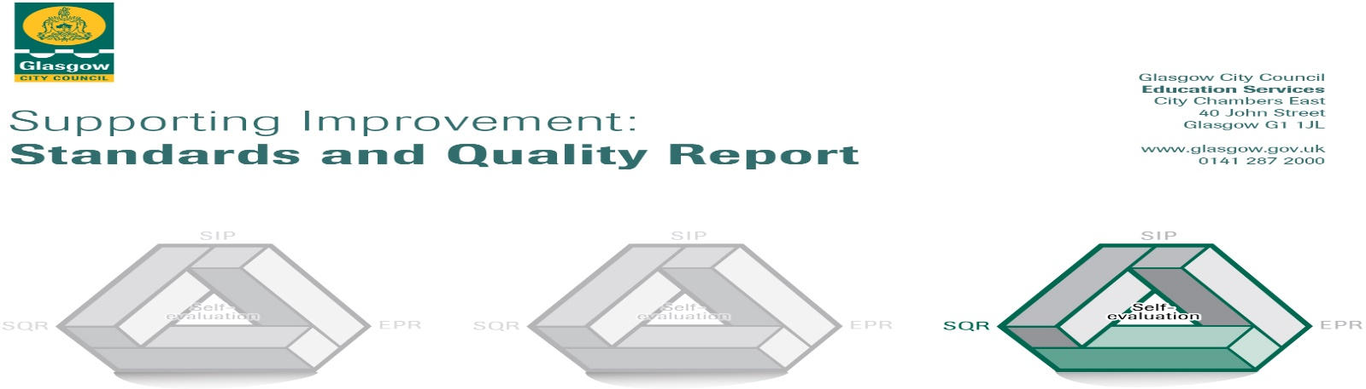
St. Monica’s (Milton) Primary School
June 2022

The summary report is provided for parents/careers and partners to outline our achievements this session and our priorities for next session. Throughout this session we have taken forward our priorities as detailed in our school improvement plan. Through our processes of self-evaluation, we have identified how we can improve outcomes for our children and young people.

Our achievements and improvements this year.
We would like to highlight the following improvements/achievements:

St Monica’s (Milton) Primary School is a strong faith community and as such our Catholic values permeate our vision, values and aims. This is evident in our curriculum and in the daily practice of all staff. This results in very positive relationships across the school based on our Catholic social teaching. Almost all children continue to be engaged, motivated and interact well during learning experiences almost all of the time.

Despite the difficult couple of years, the world has had due to the pandemic, we still continue to have a highly committed and motivated staff who engage well with our children and families in order to ensure they have relevant and meaning learning experiences. To further support our children and young people we have established two Well-being Bases in the school which allows children to work in smaller groups, develop team work skills or to aid their emotional health and well-being. We have ensured a consistent approach to this by assigning specific teachers to lead these. This works well alongside our Place2Be service we have within the school where children can self-refer themselves to talk to our Place2Be School Project Manager or identified children can work one on one with one of our Counsellors following discussion with parents and carers.

We continue to focus on improving literacy, numeracy and health and wellbeing. The majority of children are making progress in literacy and the majority of children are making progress in numeracy. This is supported with the help of our teachers, Support for Learning Workers (SfLWs), Challenge Leaders of Learning (CLOLs) and Digital Leaders of earning (DLOLs). Because of this support, the majority of
children have attained the appropriate levels in literacy and numeracy. We have also been fortunate to have an English as an Additional Language (EAL) teacher this year to help support our increasing number of EAL children. As we come out of lockdown we will ensure we work with as many of these families as possible.

To further aid the children’s learning and help raise attainment we have been incorporating the use of digital technology lead by our DLOL. We continue to use Seesaw for our Home Learning and children have access to iPads throughout the day to enhance the learning taking place. Children are now more confident and capable of using different forms of digital technology and various apps. All P7s have their own iPad and it is hoped that next year P5 and P6 will get one too. Being on this digital journey has now allowed the school to be known as a ‘Digital School’ as we were awarded this in April 2022.

The majority of P3s, P4s and P7s celebrate and make the Sacraments of the Eucharist, Reconciliation and Confirmation and supported effectively by the teachers. This is further aided by St Augustine’s Parish Catechists and Father Paul McAlinden.

Using Pupil Equity Funding (PEF), initiatives have been able to be implemented to support all children as well as aid staff’s professional judgement as to how the children are doing with their learning. PEF has supported additional staff, resources, our Place2Be Service and assessments.
Most children are making positive progress in their learning since returning to school post lockdown.

As a school, we continue to recognise the importance of working alongside our partners and hope to increase these to ensure our children have a well-rounded and positive school experience. A few of our children are able to experience music tuition within the school from our Guitar and Violin teachers. It is lovely to hear them play and see their determination in doing so.

Being part of a community of faith we have begun to set up a Community Cupboard and partnering with FareShare who supply the school with unwanted items of food from the local Tesco. We hope to continue to do this and expand what is on offer so that it can support as many families within our school as possible.
We continue to work with some of our well-established partners:
- Caledonian Club
- Sir Thomas Lipton Foundation – Buoyed Up Programme
- Place2Be

Prior to lockdown the school arranged a great deal of whole school events and had various clubs for children after school however, due to restrictions these have not been able to be organised however we intend to reinstate these as soon as possible.

School Awards:
- Cycling Friendly Primary School Award – March 2022
- Digital Schools Award – April 2022
- Eco-Schools Green Flag Award status - June 2022

Here is what we plan to improve next year.
We want to continue to focus on and improve:-

1: Health and Wellbeing - Rights Respecting Schools Award (RRSA)
Continue to embed children’s rights throughout the school and work towards our Silver Award.
2: Health and Wellbeing – Emotion Works
To develop the emotional literacy across the school.
3: Teaching and Learning - Collaborative Enquiry Process
Improving Teaching and Learning through the Collaborative Enquiry Process focusing on the Good Lesson
4: Digital Learning
To improve the use of digital technologies across the school to develop creativity skills and raise attainment through:
- Staff and pupils continue to further develop their skills using digital technologies across the curriculum
- Updating the school website and school Twitter page to share achievements and learning with the school community
- Positive transitions across Nursery, Primary and Secondary
- Working on Cyber Resilience and Internet Safety (CRIS) as the next part of achieving our ‘Digital Schools Award’
5: Raising attainment in Literacy
Our objective is to raise attainment in Literacy through:
- To raise attainment in writing in all stages across the school.
- To raise attainment in talking and listening in all stages across the school
- To further embed reading strategies particularly from P3-P7
6: Restorative Approaches
Improving Health and Wellbeing, specifically readiness to learn through the implementation of Restorative Approaches
7: Equalities and Inclusion
To ensure the safety and inclusion of all children relating to the Equality Act and the protected characteristics.

How can you find out more information about our school?
Please contact us directly if you require further information or if you wish to comment on the report.

The contact e-mail address is: headteacher@st-monicasmilton-pri.glasgow.sch.uk

Our telephone number is: 0141 772 0026

Our school address is: St Monica's (Milton) Primary School, 200 Liddesdale Road, Glasgow, G22 7QR

Further information is available in: newsletters, the school website, social media and the school handbook

Website: www.st-monicasmilton-pri.glasgow.sch.uk

Twitter: @StMonicaMilton

Facebook: St Monica’s – Milton Primary School

