 | Mrs Bates/Miss Pearson  Term1& 2 Newsletter |  | 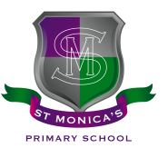
What we are learning about:
Maths & Numeracy  In Numeracy, we have been working on Place Value – Hundreds, Tens and Ones, with 2 digit and 3 digit numbers. We are also working with ourselves with a wider range of 3 and 4 digit numbers. We have also been looking at measuring length in centimetres, millimetres and metres. We are working with the appropriate tools to help us measure accurately. |  | Literacy  Reading: Our class novel has been Alien in the Jam Factory. We have been focusing on answering comprehension questions based on a text.  Writing: This term we will be focusing on Writing to inform and also writing to persuade. Talk to your child about what they have been Writing in class this term. Children are making excellent effort with their writing learning.  Handwriting: We are also practising our handwriting skills on a regular basis and children are now expected to be joining handwriting.
Health and Wellbeing
We have been learning all about the UN rights of the Child in the first few weeks of term, and have decided on which ones are most relevant and important to our own class.
Religious Education
We have been learning about the Church's Liturgical Year, the Sacraments and the miracles of Jesus. Pupils are encouraged to attend Sunday mass wherever possible.
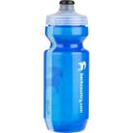 | Things to remember…  Healthy Snacks and Packed lunches  PE—Our PE days are Tuesday & Friday (No jewellery)  Please label all clothes and lunch boxes!  Fr Paul has asked for parents to see him after mass if you wish your child to receive the Sacrament of the Eucharist this school year
Our Topic…Our topic for this term is the Oceans of the World. We’ve been learning about coral reefs and ocean pollution. Why not visit the local library to see if there are any non-fiction books about this.
Homework
Homework will be uploaded onto Seesaw on a regular basis. Please support your child to complete Seesaw tasks if possible. Sumdog is an excellent opportunity for pupils to work on Numeracy at their own pace. Children have reading homework regularly too
Yours sincerely,
Mrs Bates and Miss Pearson

