 | Mrs McGowan & Mrs Steele  Primary 7B  Term 1 Newsletter |  | 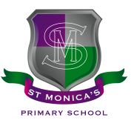
What we are learning about:
Maths & Numeracy:  This term we will continue to make links and explore connections when solving decimal, fraction and percentage problems. We will also work on our recall of multiplication facts which will support with our mental agility. In beyond number, we are focusing on estimating and converting different measurements, including length, mass and volume. Then, we will move on to data handling to create and interpret graphs. |  | Literacy:  Reading - We will continue to extend the range of fiction and non-fiction texts we enjoy. We will develop our reading strategies through daily literacy activities. Our novel this term is "Coraline” by Neil Gaiman  Writing - We will be focusing on ways we can up level our writing this term by becoming more ambitious in the vocabulary we use and adding more depth to our written work. We will become more critical with our own work to allow for improvements.
Health and Wellbeing
We will spend a lot of this term preparing our pupils for their transition to high school, identifying strategies that will best support them.
Religious Education
Primary 7 will continue to work toward achieving our Pope Francis Faith Award, and prepare for the Sacrament of Confirmation. We will spend time learning about the life of Saints and how this can impact our lives.

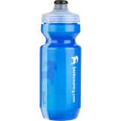 | Things to remember…  Healthy Snacks and Packed lunches  PE: Our PE days will return to Wednesday and Thursday  (remember no jewellery -  plain black leggings/shorts and plain white t shirt, with school jumper)
Other curricular areas:
The children have chosen to learn about Continents as our topic. We will conduct research about different countries, cultures and languages. In November, we will be attending Lockerbie Manor for our residential trip.
As well as this, we will be learning more about inheritance and processes of the planets.
Homework
Homework will still be issued each Monday through Seesaw, which should be complete by the Friday of the same week. We also ask that children spend some time on SumDog throughout the week. At times, children will be asked to read part of our novel.

Yours sincerely,
Mrs Steele & Mrs McGowan

